## DP Map

## Interactive Design Requirements Specification

Version: 1.0

Date: 09/10/2018

Presented by: DP Map Team

|  |  |
| --- | --- |
| Team Member 1’s Name | Nathan Cramer |
| Team Member 2’s Name | Pierson Beckman |
| Team Member 3’s Name | Manuel Harvey |
| Team Member 4’s Name | Cameron Faubion |

# **Revision History:**

* 09/10/2018 Revision # 1

# **System Concept**

*DP Map will be an Android application that allows users to input the room number of their class and get a map identifying the room they need to go to. The app will cover UNT’s Discovery Park campus.*

# **Interview/observation Notes**

Who: The primary users of this application are freshman and transfer students who may be unfamiliar with the campus.

Interview questions:

-How often would this app be useful to you?

-Would you prefer to add all your classes at once, or add your classes individually?

-How would we best indicate the location of your class?

-Would it be useful to highlight the path to your class?

-How do you get to school?

-On a scale of 1-5 how technically savvy would you rate yourself?

-What is your grade classification?

-Do you use any other apps for a similar purpose?

-Are you a transfer student?

-Would an app like this be useful to you?

-What is your age/background?

Observation Notes:

We used a google survey to collect information about our users. These are their responses. 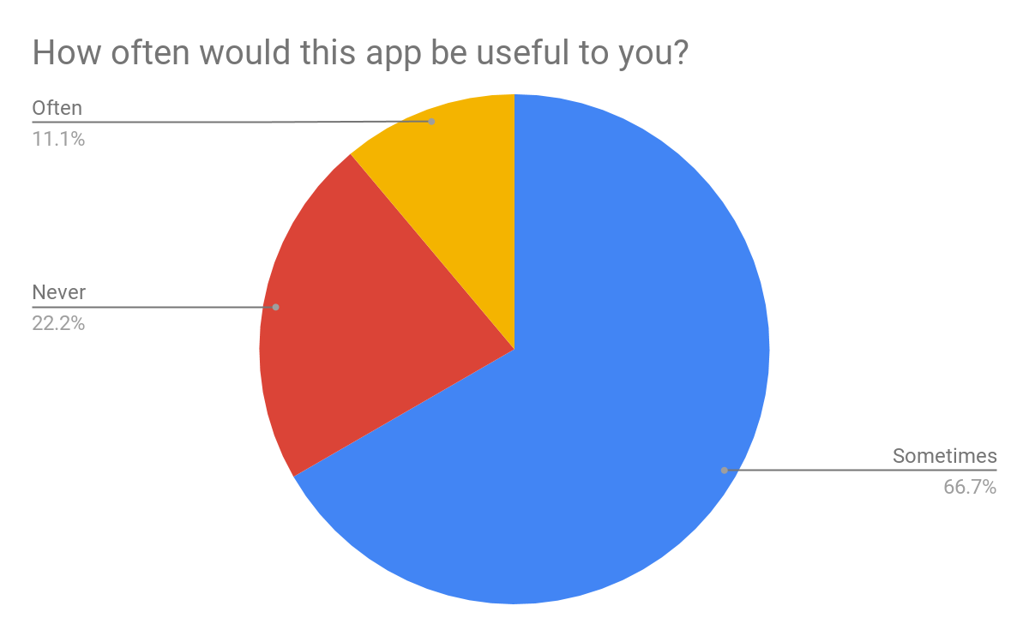

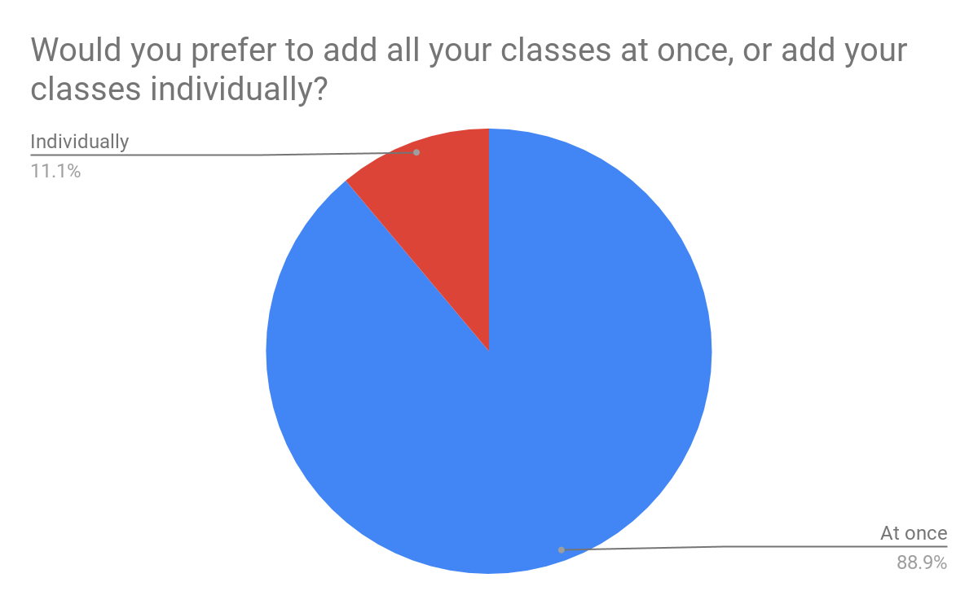

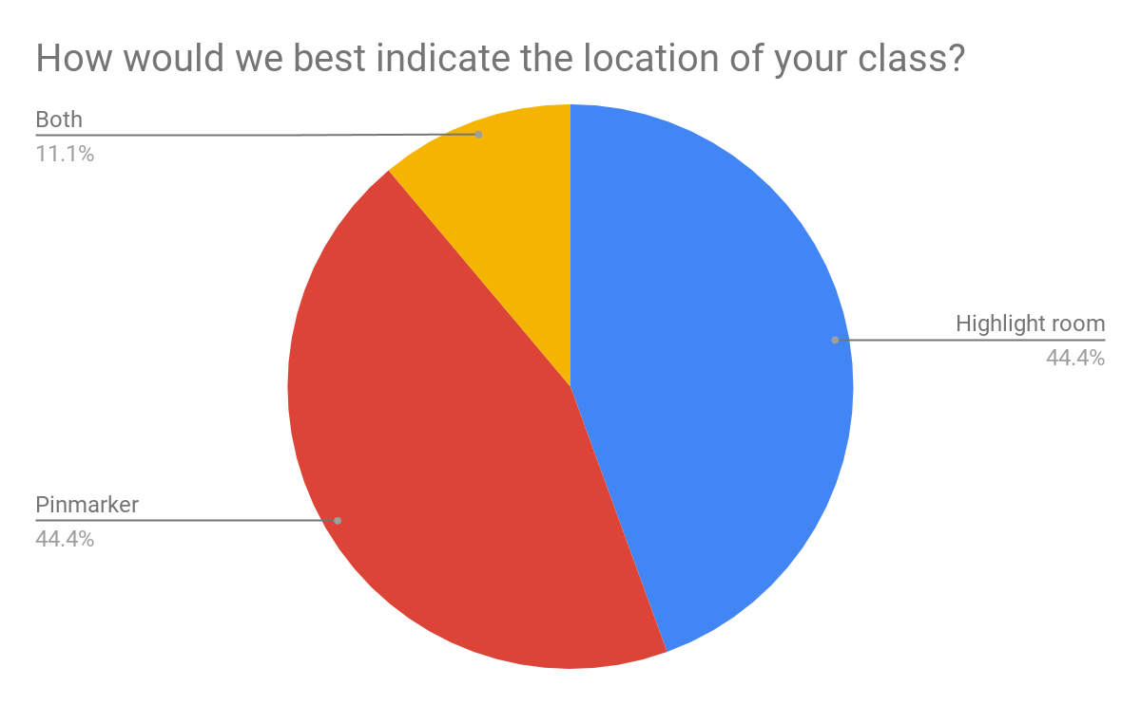

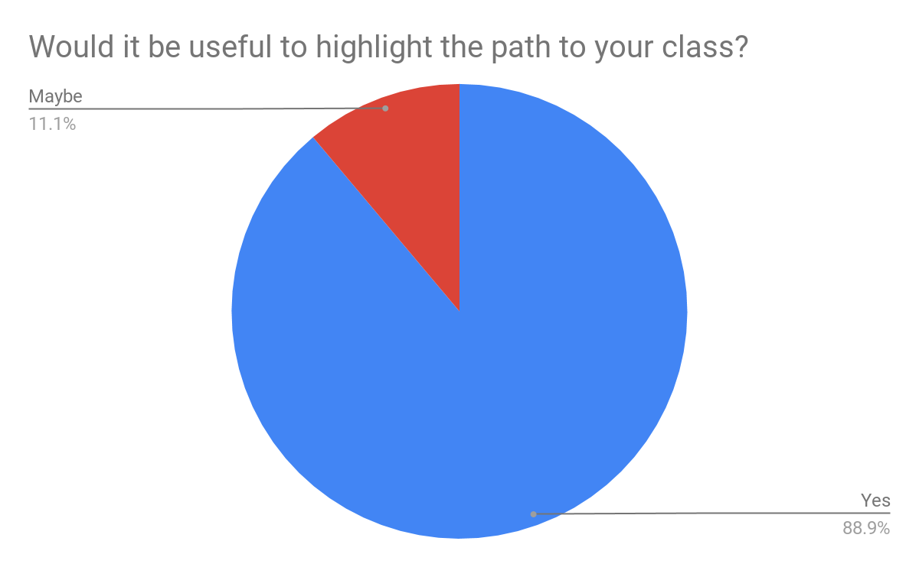

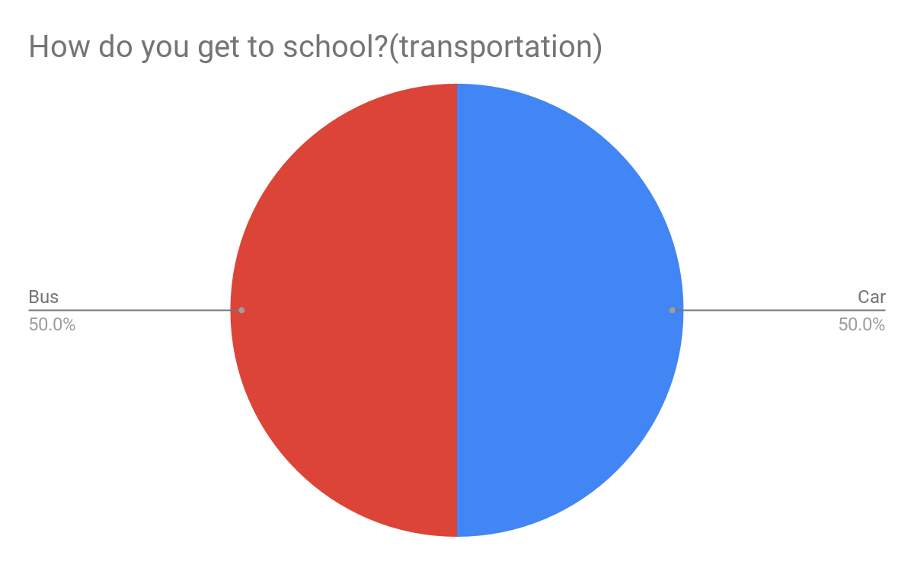

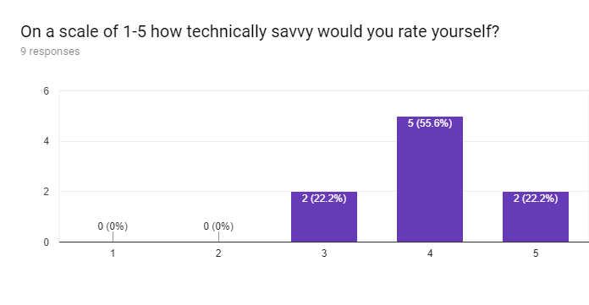

# What is your grade classification?

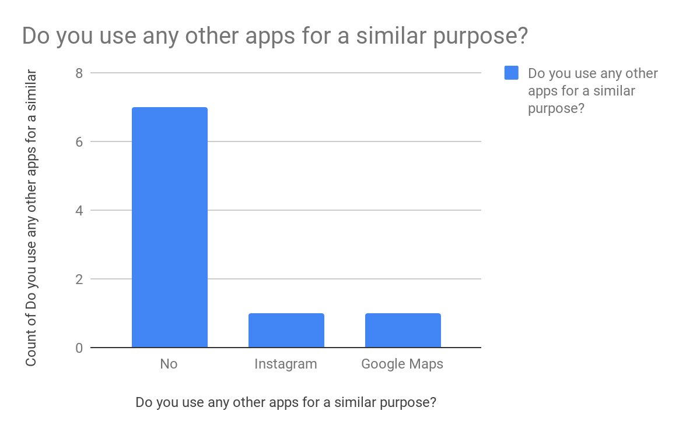

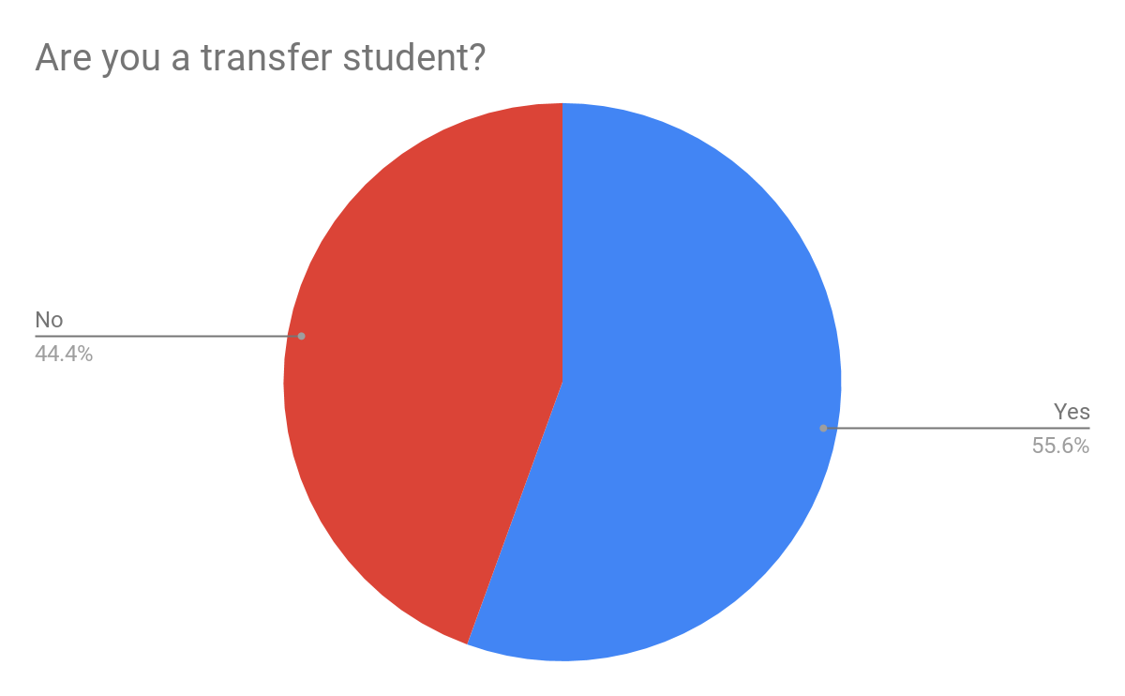

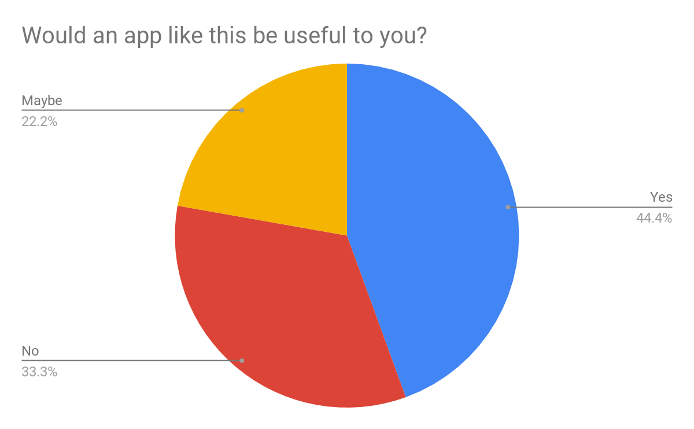

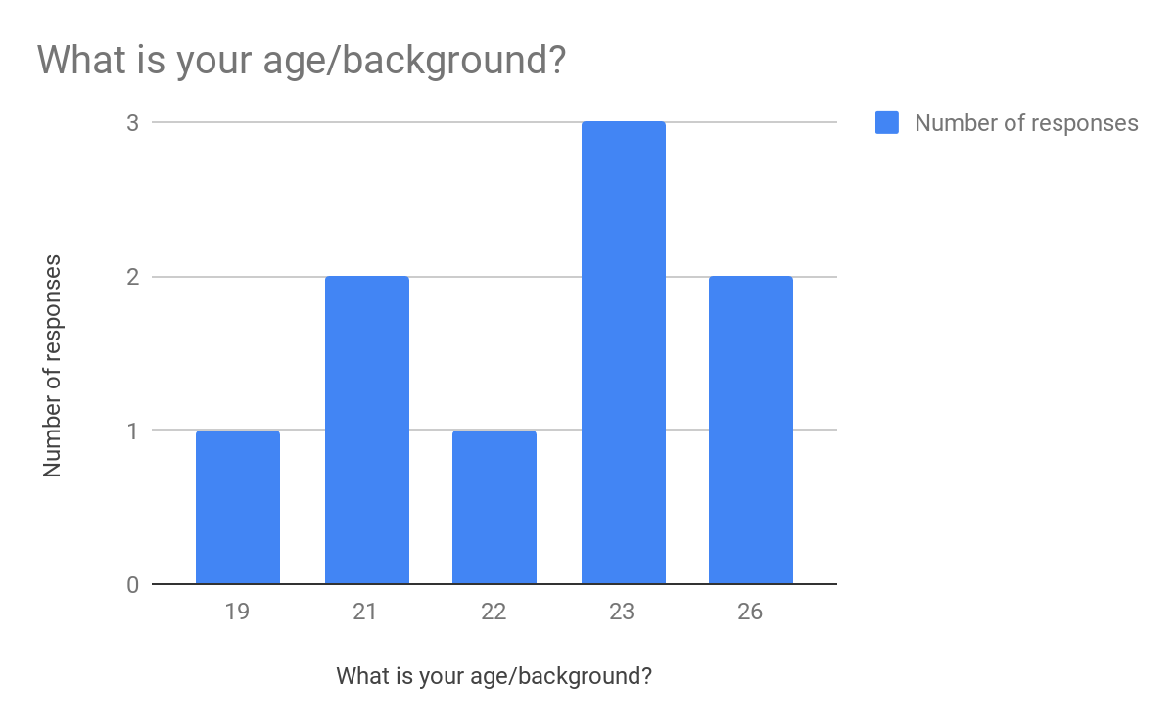

# **Work Roles**

|  |  |
| --- | --- |
| **Work Role: Freshman or Transfer Student** |  |
| Context of use | Used to find their classes. |
| Goals | Want to find their classes, but the existing apps only help them find the building. |
| Frequency of use | Used to find their classes during the first week of class. |
| Work responsibilities | The user would upload their class room numbers. |
| Work environment | At school, or at home. |
| Abilities | Literate in English. Familiar with using apps on a phone. |
| Personal | 18-30 year old college student. |

# **Functional Requirements**

**Primary:**

1: The system shall be able to read in the room information from the user.

2: The system shall be able to find that room number on a previously loaded map.

3: The system shall be able to indicate to the the room number on the map.

**Secondary:**(Not a primary concern)

1: The system shall show the optimal path way between classes

# **Usability Requirements**

UR1: The system shall be learnable in five minutes or less by most adults of college age.

UR2: The system shall be usable with one or two hands.

UR3: The system shall support both left-handed and right-handed use.  
UR4: The system shall follow UI guidelines for Android applications.  
UR5: The system shall provide a keyboard prompt when opted to enter text.